


2024-2025 EDUCATIONAL YEAR

E-TWINNING PROJECT


ID: 153492

CREATE YOUR OWN STORY



PROJECT PARTNERS

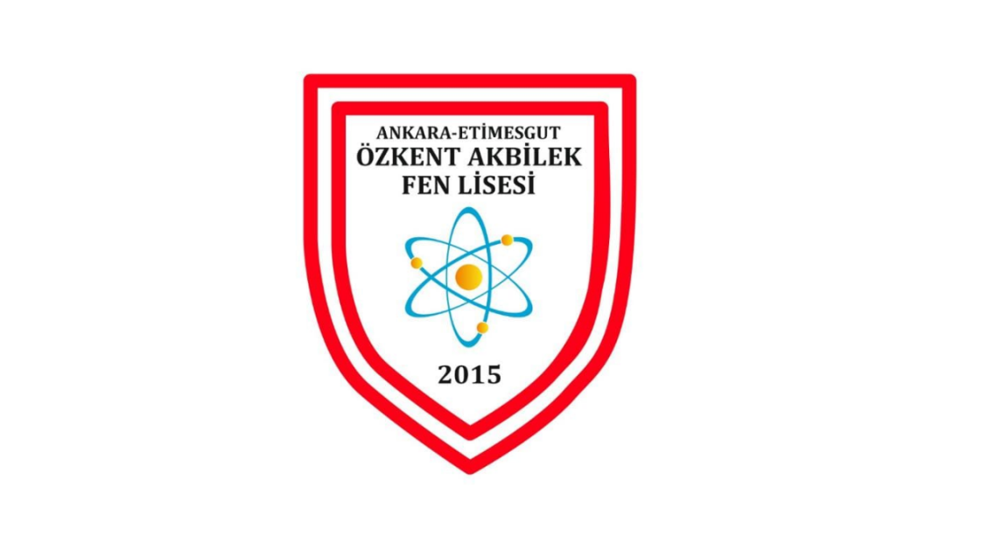

ÖZKENT AKBILEK SCIENCE HIGH SCHOOL

THE FOUNDER OF THE PROJECT: ESEN NUR GÜNERHAN

PRINCIPAL: MEHMET MUSTAFA GENÇ

STUDENTS OF THE 1ST GROUP

1.FURKAN TARTAN
2.GÖKÇE USTA
3.ZEHRA NAZ DOĞAN
4.ECRİN BÜŞRA ÖZCAN
5.HALE DÜZEL
6.BEGÜM POLAT
7.EYÜP EMRE KARAKÖSE


ISTITUTO D'ISTRUZIONE SUPERIORE
E. USUELLI RUZZA
PADOVA, ITALY

THE STUDENTS OF CLASS 2BMP

1. TAMIA
2. JASMINE
3. FIZZA
4. LUISA
5. FEDERICA
6. GLORIA
7. MALAK
8. ATEYA

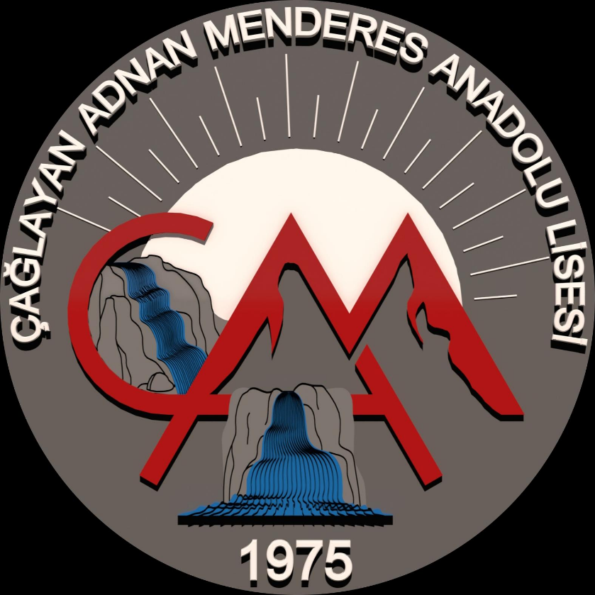

ÇAĞLAYAN ADNAN MENDERES ANADOLU LİSESİ

PRINCIPAL: İsmail Yiğit

TEACHER: DİLBER OKUR

STUDENTS

1.HATİCE
2.NİSANUR

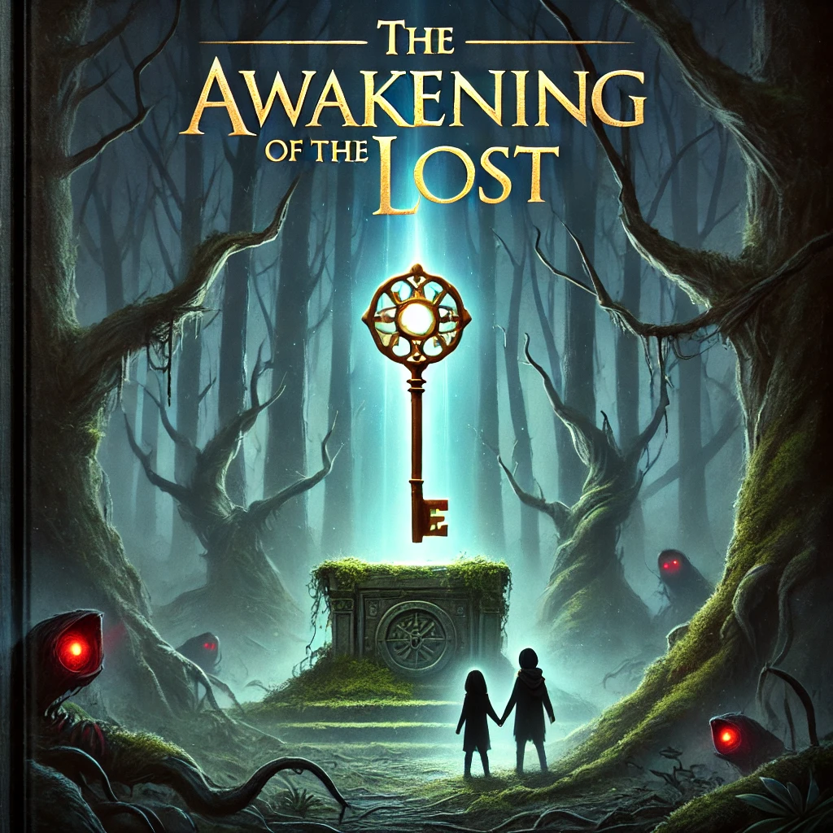

THE AWAKENING OF THE LOST

DRAWN BY

Jasmine / ITALY
BEGÜM /TURKIYE

THE CHARACTERS

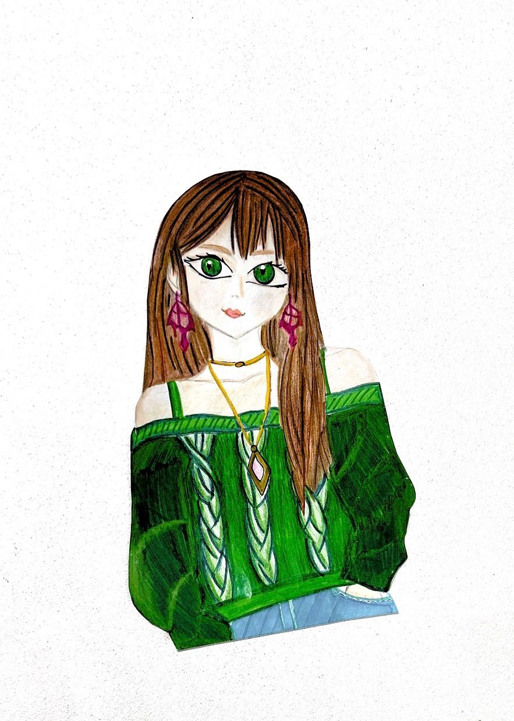

ADELE

It was an ordinary day for Adel, she got up from her bed for school in the morning and started to get ready. She went in front of the mirror and carefuly combed her brown straight hor, her green eye s were looking at the mirror lively, this was a rare thing because she usually hated getting up earl y in the moming and going to school with sleepy eyes but to day was the school picnic and they were going to go to a picnic in a forest far from school. She left home and got on the school bus, when she antved at school everyone was in line to get on the buses When she got in line she saw her besfriend Amelia.
Adel where are you everyone took the back seats, and I waited for you to get in line, Amelia said. The bus was late, is there no room left in the back seats? Adel expressed her sadness
No, there is no room this is the last bus anyway, come on, let's get on, if we sit in the front we can arrange the song, lets think positivele she said and started pulling Adel
Okay, okay I'm coming Amelia, can you leave my shirt, Adel said and chuckled.They got on the bus and sat on their seats. Everyone in the back seats was laughing and throwing bottles at each other. Everyone seemed to be having fun until one of the bottles thrown from the back hit Min. Catherine Darian, you switch places with Edwin immediately. Mrs. Catherine practically shouted. Darian grumbled and sat on the single seat next to Adel. As the journey continued, the driver said, "We have a problem," and pressed the brakes, but the brakes were not working. Everyone started looking cut the window and saw the scary sight. The road that was supposed to continue normally was suddenly cut off and tumed into a cliff. The bus was heading towards the void and the brakes were not working.

Open the doors, lets jump on the road, then we can call for help. Adel said Darian nodded in opproval. Mrs. Catherine told everyone to come to the front. Adel and Durian stood in front of the door, there was a huge crowd behind them, the driver opened the door, the bus was very close to the cliff. Adel and Amelia were holding hands, but Amelia was in the middle of the crowd. Darian shouted, "On the count of 3 and started counting loudly
Adel looked at Darian with fearful eyes.
Darian held Adels hand,
One,two and three…

Adel and Darian said at the same time. They jumped. Adel could no longer feel Amella's hand in his palms, the last thing he came was the people on the bus throwing themselves off the cliff when they thought they were on the road Do you hear me? There was a hard fall. Are you conscious? Adel heard Darian's voice asking, she realized that she was lying on the ground with his mouth down. She was in gress pain and turned his head towards Darian. Darian was getting up from the ground. The driver had thrown himself onto the road at the last moment but he didn't seem to be alive. Darian checked his pulse, unfortunately, the driver was not alive

What are we going to do now Adel said

"This is not normal at all said Darian What is not normal?" asked Adel

Normally this road is straight and we have been to the same picnic area many times with my friends. It is not normal for it to be cut like this answered Darian

We have to call for help," said Adel and called his phone but he found his phone broken on the ground because she had a hard fall Darian had left his phone in his bag on the bus.
Great said Adel regretfully.It looks like well be spending the night here lets go go he forest at least we'll find something to eat, Darian sad. "The forest in not safe at all, no one can find us there, Adel said, malking point clear.

However, Darian objected, saying, "We have no other choice. If we stay here, we'll starve to death. At least in the forest, we might find something to eat and survive."

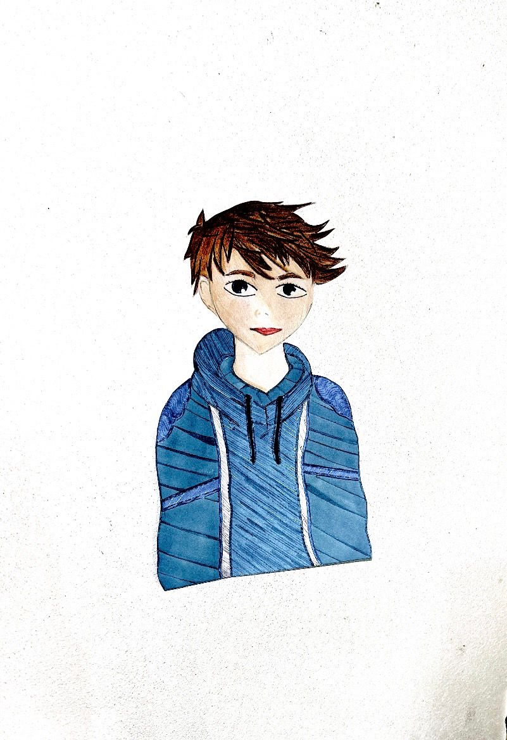

DARIAN
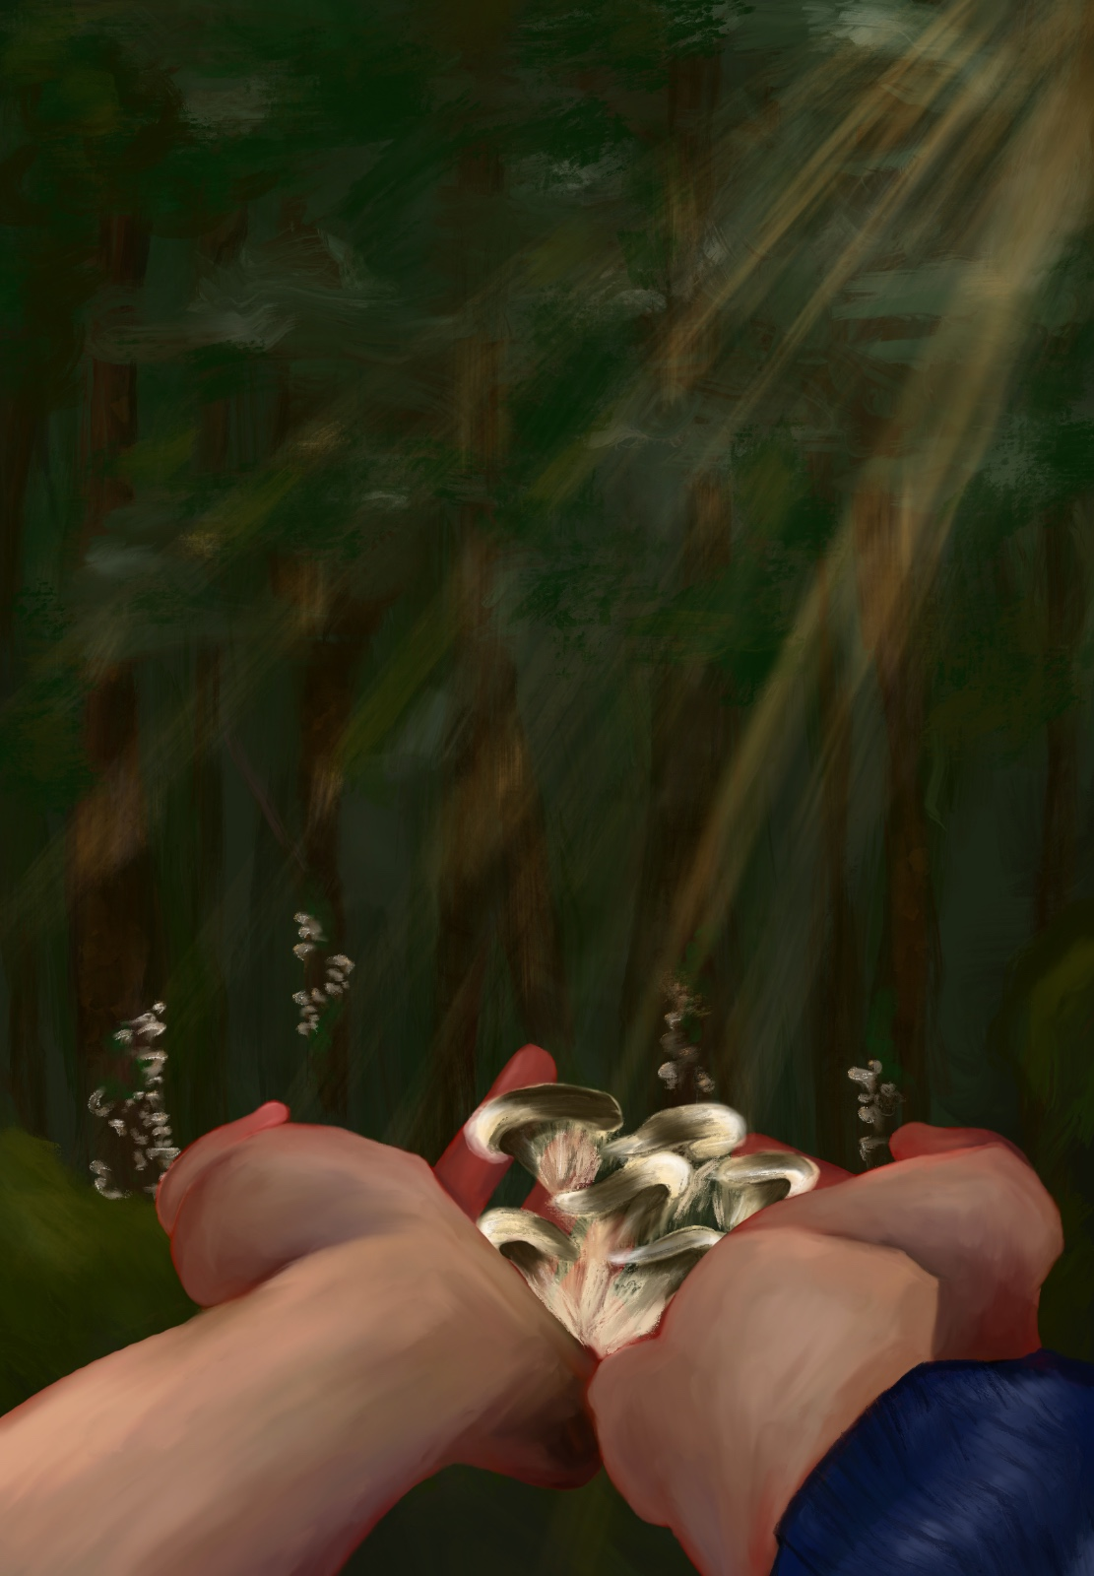

This time, Adel agreed with him. Together, they began walking toward the forest. Darian led the way, carefully scanning the surroundings to protect Adel from sudden dangers. After walking for a while, they noticed mushrooms growing near a tree and approached them.

Adel asked skeptically, "Should we take these? Could they be poisonous?"

Darian smiled and replied, "If you had paid attention in class, you'd know. These are oyster mushrooms, a non-poisonous type."
Adel let out a hum of acknowledgment. They gathered the mushrooms and continued on their way. As Darian carried the collected food, Adel began gathering branches to build a fire. However, due to her delicate frame, she couldn’t carry some of the heavier branches. Darian noticed this and took part of the load to help her. Scanning the area with his sharp eyes, Darian realized they had gone too far.
"We shouldn’t go any further. Let’s head back. We need to call for help before it gets dark," he said calmly.
Adel was scared but didn’t want to stay and risk dying there. She followed Darian’s lead, quickly walking back to the bus. Once they arrived, Adel placed the branches she had gathered on the ground and arranged them to build a fire. Everything seemed to be going well until Adel noticed something.
"Darian, we’re going to make a fire, but we don’t have a lighter or matches," she said sadly.
Darian frowned and began checking his pockets.
"I should have taken them with me when I left home," he thought.
After searching for a while, he finally found the matches. Adel’s green eyes lit up with joy as they met Darian’s hazel ones. Darian took the matches and tried to light a fire. After some effort, the fire blazed up. Both of them were freezing and immediately moved closer to the fire to warm themselves. Darian began cooking the mushrooms. They had gathered enough to last at least a day. Once the mushrooms were cooked, Darian handed the first piece to Adel. She was so hungry that she ate it immediately.

"Thank you, Darian. I wouldn’t have survived this long without you. I’m so glad you’re here," Adel said gratefully.

"You’re welcome, Adel. Let’s finish our meal and call for help. We need to hurry," Darian replied.

"You’re right. Let’s eat quickly."
Darian and Adel quickly ate the mushrooms. Adding a few more branches to the fire to keep it alive, they set out to call for help. "Maybe the driver’s phone still works," Darian thought as he slowly approached the driver.
Adel, overcome with sadness about their situation and their friends, couldn’t hold back her tears. Darian searched the driver’s pockets and pulled out a phone from the back pocket. The screen was cracked, but it worked well enough. Darian immediately tried calling the police, but what he feared happened—there was no signal.
"Adel, I found the phone, but there’s no signal. If we go a bit further, we might find a spot with reception," he said with a heavy heart.
Adel nodded, and they started walking. As Darian searched for a signal with the phone, he thought about where they could go. They walked for a long time. By then, the sun was starting to set, and Darian was on the verge of giving up.
"It’s getting dark. If we keep going, we won’t be able to find our way back. Let’s head back now and try again tomorrow," he said, defeated.

They returned to the bus. Darian tended to the fire, which had started to fade, while Adel sat down, lost in thought.
How had this happened? How had the path they always walked suddenly turned into a cliff? She stood up, fearfully approaching the edge of the cliff with the hope of seeing her friends, but when she looked down, no one was there.

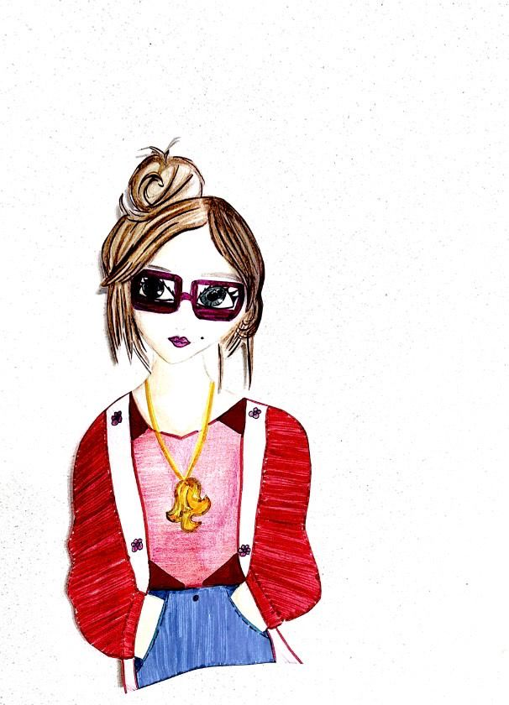

AMELIA

How could this be? She had seen it with her own eyes. Everyone had fallen off the cliff.

Adel ignored it and se went to sleep beside Darian. At a certain point of the night she was suddently woken up by the screams of her friend: he was nowhere to be found! Scared, she ran into the forest and hide behind a bush, and what she saw disgusted her: Darian, the only friend she had left, were chased by a strange figure in the dark that was obviusly non-human. She had to decide: stay in the bush and let her friend die or help Darian and risk her life; she grabbed a brunch that was nearby and decided to attack the monster, Adel smashed it into the face of it and ran in the forest whit her friend.
After a while,Darian spoke:

"Thanks, Adel. Whithout you at this point I would be dead!"
Adel: "No problem, but what happened?"
Darian: " I'm not sure why it started to chase me, but I remember that I felt something touching my face, and there it was, that monster!"
Adel: " But what was that? I couldn't recognise it"
Darian "Me neither, but I know these 2 things: It was non-human and it can't be killed, but it obviusly wanted to eat us, that's why you couldn't saw the bodies of our dead friends."
At that point, they started to walk as far as possible to look for help, but they started to lose faith.

Morning came, Adel and his friend walking through the woods found a little house built in wood. The position of the house was so perfect that they thought someone lived here. Adel say to Darian: "Who could come to live in the middle of this scary and restless woods?"

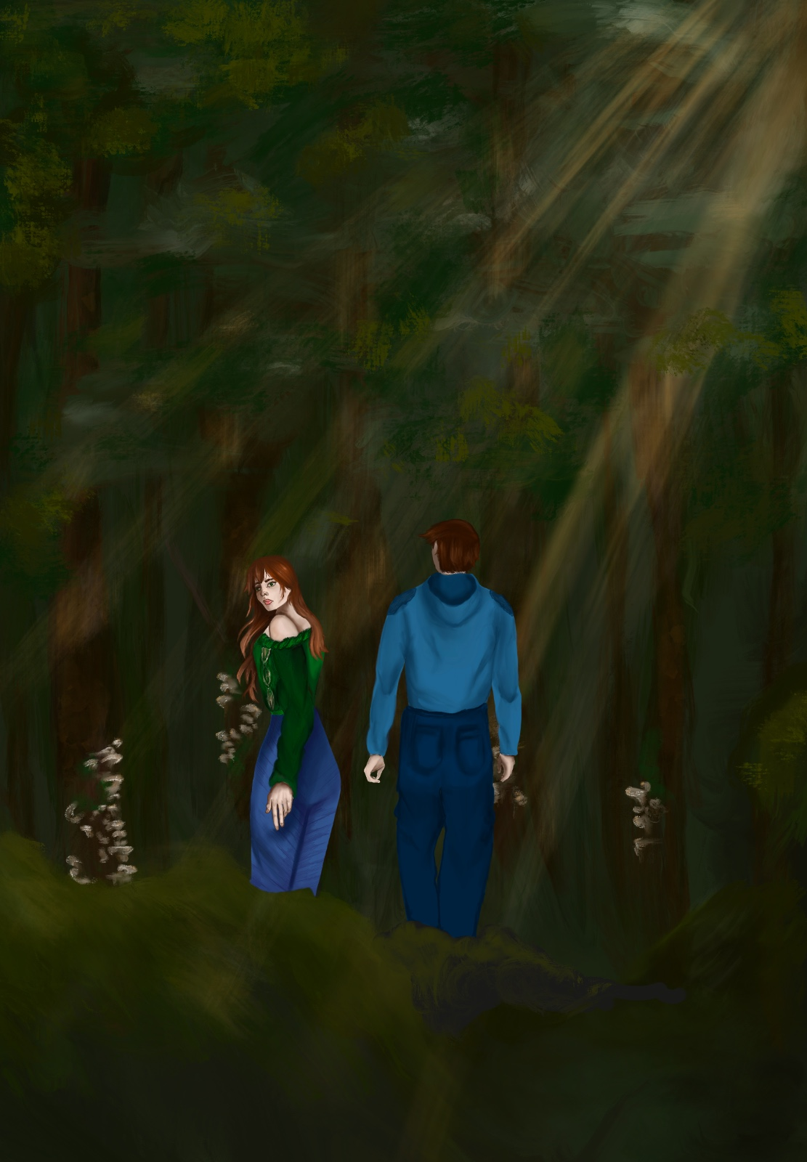

Darian replied: People who have such a dark soul to the point of doing harm, Adel...
Adel and Darian were head closer and closer to this little house. The forest was quiet, there was no noise, but, the only noise that scare Darian and Adel was that crunch of the leaves. Every step they took seeme so mysterious and disturb.
The two got so close that they could see something moving through the door lock, it was a lynx!
Darian look! "He has blood red eyes, different from the lynx I imagined."
The lynx looked at them, was so scared that it managed to take Adel cornea.
-Adel!:Are you okay? It would have been better if he taken me rather about you!
Adel said to Darian, "I'm fine, don't worry..."
Darian was so worry that I thought of find anything to heal her wound. And yes...that lynx, she was possessed.
Darian said to Adel: Let's get out of this place own now!.

Adel and Darian look into each other's eyes. Adel gently took Darian's hand and they ron together.
Walking down the path, Darian saw something shiny, it was a pen with a handkerchief around it.
Darian exclaimed: oh Adel, i gave a handkerchief for you! for your eye!.
Adel started cry, he couldn't believe it.
Darian said: Come, I'll disinfect your eye, so you can see like a facon .
Adel and Darian sit in a rock that was green, like Adel's eyes. And from that moment on, Darian took care of Adel.

As Darian cleaned and wrapped Adel’s wound, the forest grew even quieter. It was as if the very trees were listening to their conversation. After a moment, Adel tilted his head slightly and looked at Darian. “Darian, that lynx… those eyes… I felt like it was trying to say something,” he said, his voice trembling.
Darian froze. “Adel, what are you talking about? That animal attacked you. Don’t overthink this,” he replied, though he could sense something strange in Adel’s expression.
“No, Darian… It was as if that creature was warning me,” Adel continued. “Something is wrong in this forest. We shouldn’t be here, but… we need to uncover something before we leave.”
Darian furrowed his brows. “This is madness. I’m trying to save you, and you’re

thinking about staying in this cursed place? We need to leave now!”
But just as he said that, a soft breeze passed through the trees, making the branches creak with an eerie sound. What caught their attention was the whisper carried by the wind:
“There is a secret here…”
Adel and Darian looked at each other. Was the whisper real, or were their minds playing tricks on them? Darian stood up, gripping Adel’s hand tightly, and whispered, “We can’t ignore this. If something is hiding here, something that could hurt us—or others—we need to find out.”
Adel hesitated but eventually nodded. “Then we’ll do it together,” he said.

Adel and Darian decided to follow the whispers, even though fear gripped their hearts. They moved carefully through the forest, keeping their steps quiet. The trees around them seemed to grow closer, and the air felt heavy. After walking for what felt like hours, they came across a strange stone circle covered in moss. In the center of the circle was a large wooden box with strange carvings on it. Adel hesitated, but Darian stepped forward, saying, "We need to see what’s inside."

When Darian opened the box, they found an old map and a small, glowing orb. The orb’s light was soft and pulsing, as if it were alive. The map showed a path leading deeper into the forest to a place marked with a red "X." Adel picked up the map, her hands shaking. “This must be what the whispers wanted us to find,” she said softly. Darian looked at the orb and then at Adel. “We’ll take the orb and follow the map, but we need to be careful. Whatever brought us here isn’t friendly.”

As they started on the path shown on the map, the forest seemed to come alive around them. The trees whispered louder, and shadows moved just out of sight. The glowing orb lit their way, but it also made them feel like they were being watched. They didn’t know what they would find at the end of the path, but they knew one thing—they were no longer alone in the forest.

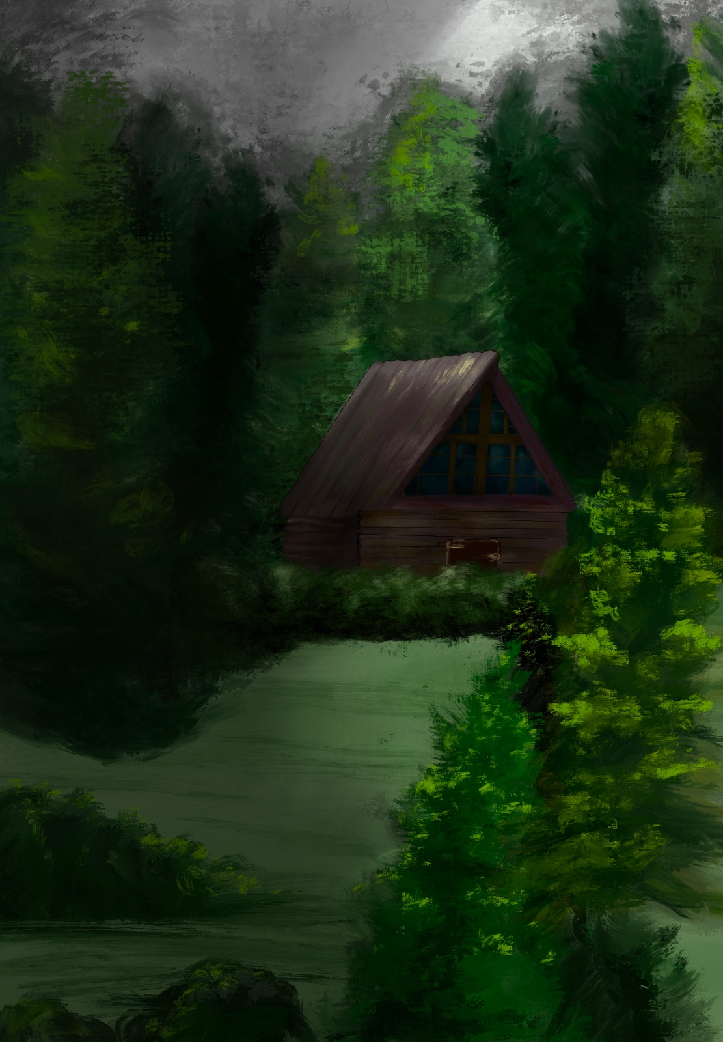

Adel and Darian kept walking feeling more and more scared,the air around them felt heavy and the path was dark.
"Darian, do you feel that too?" Adel asked, looking around..Darian didn't answer but he nodded.
Suddenly they heard a noise behind them,Adel turned quickly but no one was there. "Someone is following us” Adel said worried.. Darian smiled to try to calm her down"stay close to me"he said.

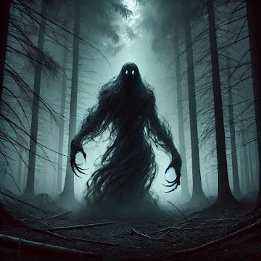

They kept going hoping the map would take them to the right place, the orb shone brighter like something was near, when they reached an open space they saw a dark figure standing in their way.
The figure was tall, covered in shadow, with glowing eyes.
"You shouldn't be here” it said in a deep voice. Darian stepped in front of Adel to protect her
"We need to pass”he said, though he sounded scared.
The figure looked at them and then spoke"Prove that you're strong enough, or turn back” the ground started to shake and a cold wind blew through the trees.

As the figure watched them Adel and Darian stood still in fear Adel said "What does he want from us?"he asked, his voice shaking, Darian looked at her scared, then he said "I don't know, but we have to be careful".
At some point the figure disappeared into a wooden house, as if he was inviting them to follow him.
"We can't stay here" Adel said, "We have to find a way out" he replied, but his gaze was fixed on the door. They decided to enter.
Inside the air was cold and heavy. The house looked abandoned, but there was something strenge about it,
Old, dusty items were scattered everywhere, Suddenly the door slammed shut behind them "We're stuck" Adelexclaimed, trying to openit, but couldn't.
Darian looked around the room. There on a table, was a small box with strange engravings, "We need to open it" Darian said.
Adel approached, but something moved behind them so scared they thought that perhaps it was better to run away, but the had reappeared figure.

When the figure appeared again, it raised one dark arm and pointed at the small box on the table. The room became colder, and the air felt strange. Adel and Darian felt scared, but they couldn’t stop looking at the box. Slowly, Darian reached out and opened it. Inside was an old key, glowing softly with a blue light.
As soon as they took the key, the figure spoke louder, its voice full of anger. “You took something that is not yours. Return it, or face the curse of the forest.” Suddenly, the ground started to break, and moving roots came out, grabbing their legs like snakes. Adel screamed and tried to free herself. Darian, holding the key tightly, shouted, “This must be the way out!” Without thinking, he put the key into a hidden slot on the wall. The room shook hard, and a secret door opened. The figure let out a loud, terrifying roar.

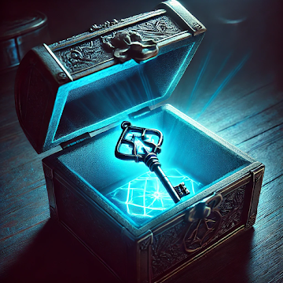
Adel and Darian didn’t waste any time. They ran through the secret door, leaving the roaring figure behind. The door led to a small dark tunnel. “Keep going!” Darian yelled. The tunnel began to collapse behind them, forcing them to run faster. Just as they thought they wouldn’t make it, they saw a light at the end. They reached the end, breathing hard. Adel turned to Darian. “Do you think it’s over?” she asked. Darian held up the glowing key. “Not yet. This key must open something important… and we’re not safe until we know what it unlocks.”

Adel and Darian emerged from the tunnel, stepping into a dark clearing. In the center stood a stone temple, ancient and overgrown with vines.
They stopped in front of the ancient stone entrance, feeling tired and scared. Darian held the glowing key and looked at Adel. “This must be the way out,” he said.

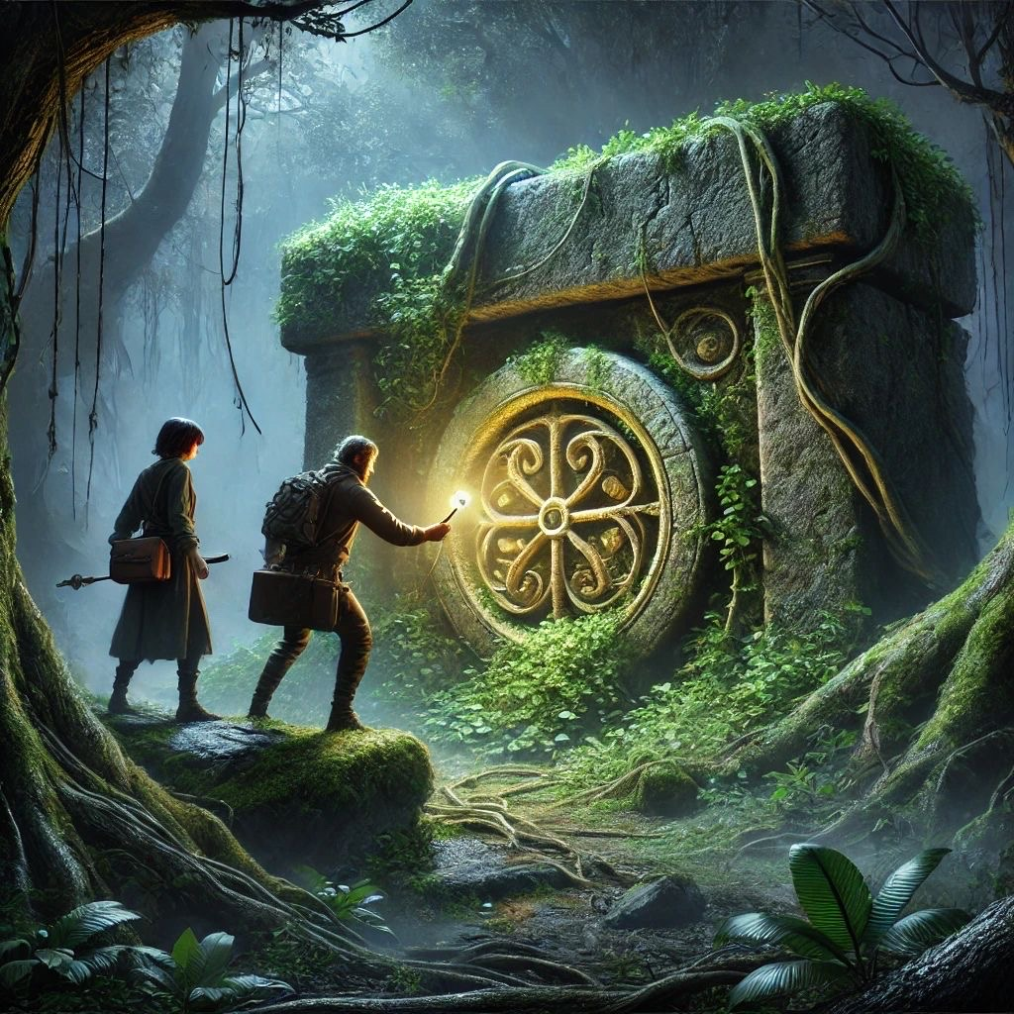

Adel nodded. “Let’s not wait any longer,” she replied. Darian walked up to the entrance and inserted the key into a small hole in the stone. For a moment, nothing happened. Then, the plants around the passage shifted away.
Adel looked at Darian. “Do we go in?”
Darian took a deep breath. “We’ve come this far. We can’t stop now.”
Without another word, they held hands and stepped through the passage, not knowing what waited for them on the other side.Adel and Darian emerged from the tunnel, stepping into a dark clearing. In the center stood a stone temple, ancient and overgrown with vines.
They stopped in front of the ancient stone entrance, feeling tired and scared. Darian held the glowing key and looked at Adel. “This must be the way out,” he said.
Adel nodded. “Let’s not wait any longer,” she replied. Darian walked up to the entrance and inserted the key into a small hole in the stone. For a moment, nothing happened. Then, the plants around the passage shifted away.
Adel looked at Darian. “Do we go in?”
Darian took a deep breath. “We’ve come this far. We can’t stop now.”
Without another word, they held hands and stepped through the passage, not knowing what waited for them on the other side.

As Adel and Darian stepped through the ancient passage, they found themselves in a large underground chamber. The walls were covered with strange symbols, glowing faintly in the darkness. In the center of the room stood a stone pedestal with a small locked chest. The key in Darian’s hand began to glow brighter, as if guiding them. He carefully placed the key into the chest’s lock and turned it. With a soft click, the chest opened, revealing an old book with yellowed pages. Adel picked it up and saw strange writing inside. “This must explain what happened to the road, the bus, and… our friends,” she whispered. Darian nodded, his face serious. “Then we need to understand it—before it’s too late.”

Suddenly, the ground trembled, and a deep voice echoed through the chamber. “You have unlocked the truth, but will you survive it?” The walls around them started to crack, and dark shadows crept out from the openings. Adel and Darian looked at each other, fear in their eyes. “We have to get out of here!” Adel shouted. Holding the book tightly, she grabbed Darian’s hand, and they ran back toward the entrance. As they crossed the threshold, the temple began to collapse behind them. They barely made it out before the entire structure was buried under stone and dust. Breathing heavily, they looked at the book in Adel’s hands. “This isn’t over,” Darian said, determination in his voice. “But now, we have the answers—and a chance to stop whatever is behind this nightmare.”

Adel and Darian, as they searched for their missing friends, began to feel the dark forces within them becoming more and more apparent. The book was no longer just guiding them; it felt like a curse, weighing heavily on them. "Everything comes with a price," Adel thought, trying to push away the terrifying thoughts in her mind. The book revealed that the missing people were not just victims; they were keys—keys powerful enough to unlock an ancient spell.
One night, amidst the whispering wind and deep darkness, Darian and Adel stumbled upon the ruins of a long-forgotten village. This was the place mentioned in the book. The remnants of the settlement seemed untouched by time, as if the world had passed it by. "There must be something here," Darian said, spotting a movement in the shadows. Taking a deep breath, trying to calm his racing heart, they stepped inside.
As they neared the center of the village, a dark figure suddenly appeared. Its eyes gleamed with a coldness that froze the night. "What is your business here?" the figure asked, its voice echoing with the weight of thousands of years. Adel and Darian exchanged a glance, unsure of what to do. This was no longer a game that could be solved by simply running. They now felt that not only time, but fate itself had started working against them.
"Truth will come to light," the figure said with a smile. "But first, you must make a choice."

You will either stay and fight, or you will push your friends, your friends and the dozens of people you left behind into eternity. ”
“Youres have 10 minutes to make your choice.”
Adel and Darian looked at each other. In everyone’s eyes, they had the same decision systems. “We are ready to fight,” they both said at the same time in a strong voice. And the voice was heard again.
“Then your first task is to find the three purple diamonds in the Opelius cave. After your first mission, our second mission begins with diamonds. In your second mission, you’ll only need to separate one of Phoenix’s feathers. And you will come here for the last mission. ”
Adel asked curiously: “So how do we find the location of all these things you said?”
A piece of paper fell from above in front of his feet and the sound started to get louder again.
“Find your way with this map”
And there was a deep silence. Adel and Darian now left where they left off and started their mission. They continued to move forward to leave the area they were in. Adel was afraid but did not tell Darian.When Darian turned, he looked at Adel and saw the concern in her eyes. He held her hand tightly to encourage . Adel also took her hand. He felt better and safer now. After walking for a long time on the road, they came across a staircase with a hundred steps. They didn’t give up and started climbing the stairs. When they got tired, they rested for a while and continued to climb the stairs one by one without giving up. And finally they managed to open a door for themselves. There was a little light inside and it was very old. They passed through a long corridor, a large hall was empty and there was nothing. Darian asked worriedly.

Adel replied, “Of course, but we can’t turn back now.”
Darian sighed. They were both scared, and on top of that, they couldn’t find the trapdoor where the diamonds were supposed to be. They kept walking and, along the path, they saw a small wooden plank. Adel lifted it, and underneath, they found the three diamonds. Now, all they were missing was the phoenix feather, but the map didn’t mention anything about it. Darian exclaimed, “The book!”
Adel opened the book, flipped through the pages, and read that there was a phoenix nest 300 steps to the right from where they were. So, they ran to the nest.
Out of breath, they arrived and found only one phoenix. Darian accidentally dropped the book, scaring the phoenix, which flew away.
Adel shouted, “Darian, are you stupid?!” and burst into tears of despair.
“What do we do now?” she asked between sobs.
She looked up at the sky and saw a feather falling from the nest.Adel hugged Darian. “Let’s go back to the voice,” she said, and they immediately started running.When they arrived, they placed the feather and the diamonds on the ground.The voice told them to touch each diamond three times with the phoenix feather and to have faith.

They looked at each other, worried, then held hands and began touching the diamonds.
A bright purple light spread throughout the forest, illuminating everything, and from the diamonds emerged three stunning, majestic purple angels radiating positive energy.
Adel and Darian were moved by their immense beauty.
One of the angels, the largest, simply said, “Follow us.”
They followed the angels, who led them to the site where the bus had crashed, where all their companions’ lifeless bodies lay. The angels kissed each of the deceased one by one, and slowly, they all came back to life. Then, the angels disappeared. Adel and Darian burst into tears of joy, but their companions were confused. They guided the others out of the forest, and on the way back, they found their families, who had started searching for them when no one had returned. Everyone ran to their families, and they all lived happily ever after. Five years later, Darian and Adel got married and wrote a book about their experience, which became very successful.

THE END

